# Template for Project Report WDD

## Group: S

Team member (id and name, Github link): x23405724 Tom Brophy <https://github.com/TomBrophy101>

## Links:

Deployed: <http://tom-brophy.42web.io/>

If video report, video link: Null

# **For those doing the written report:**

## Screen shots of Wireframes:

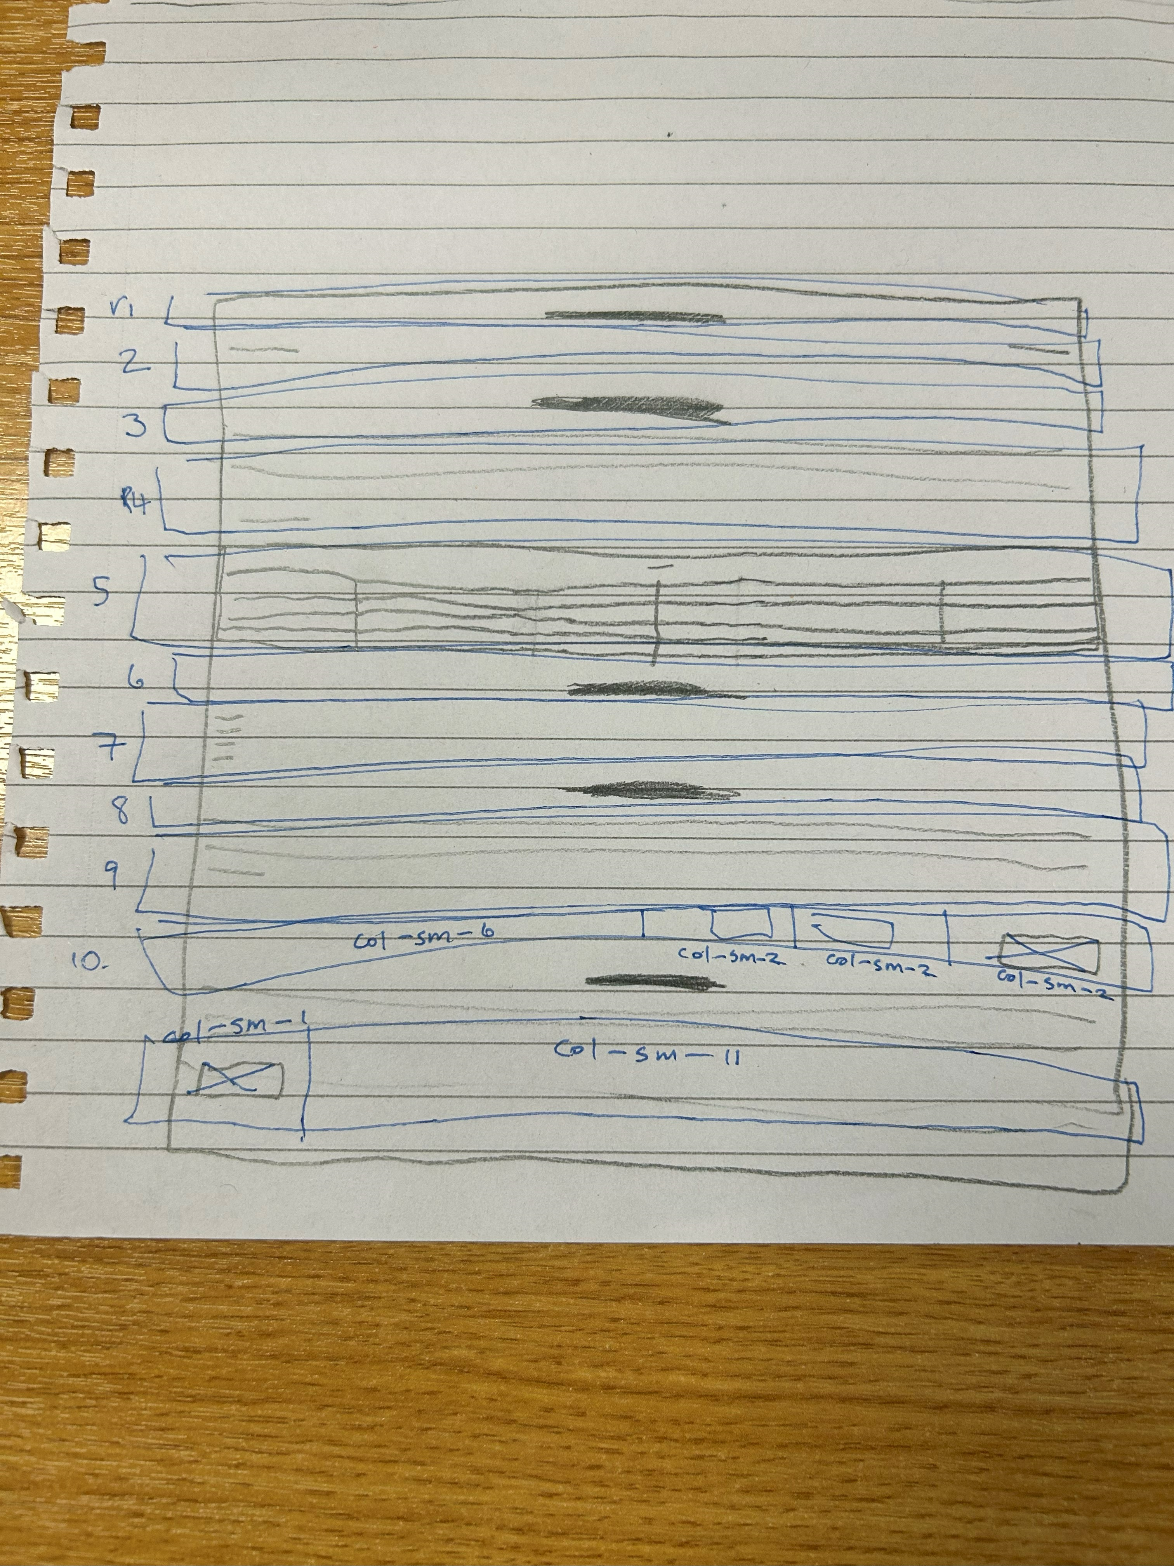

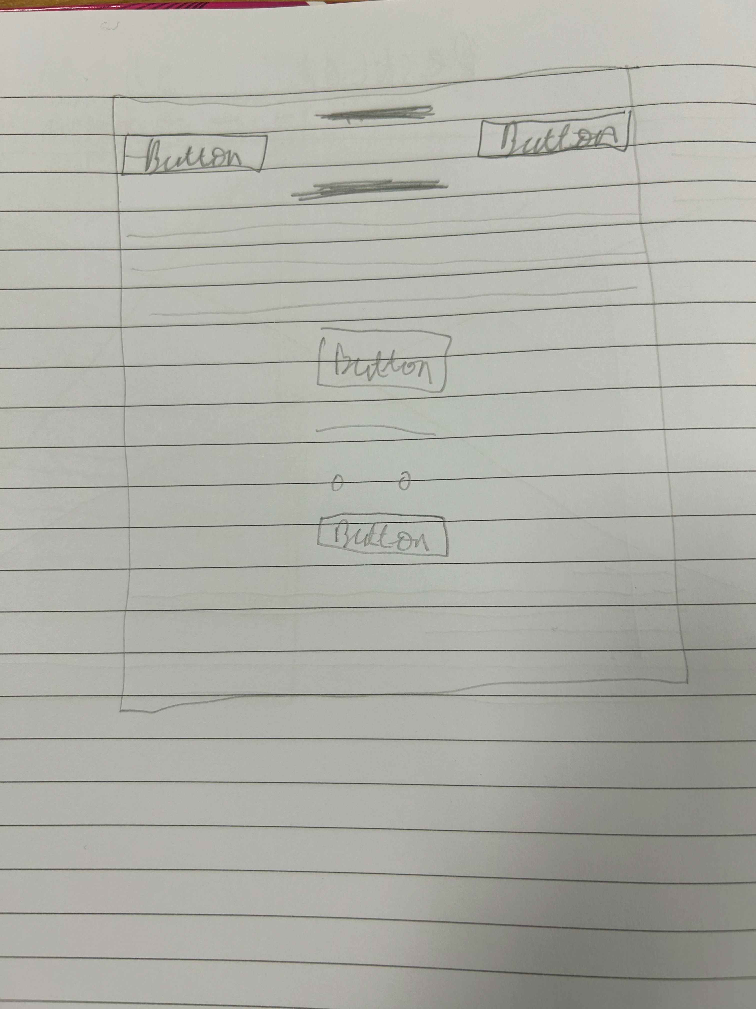

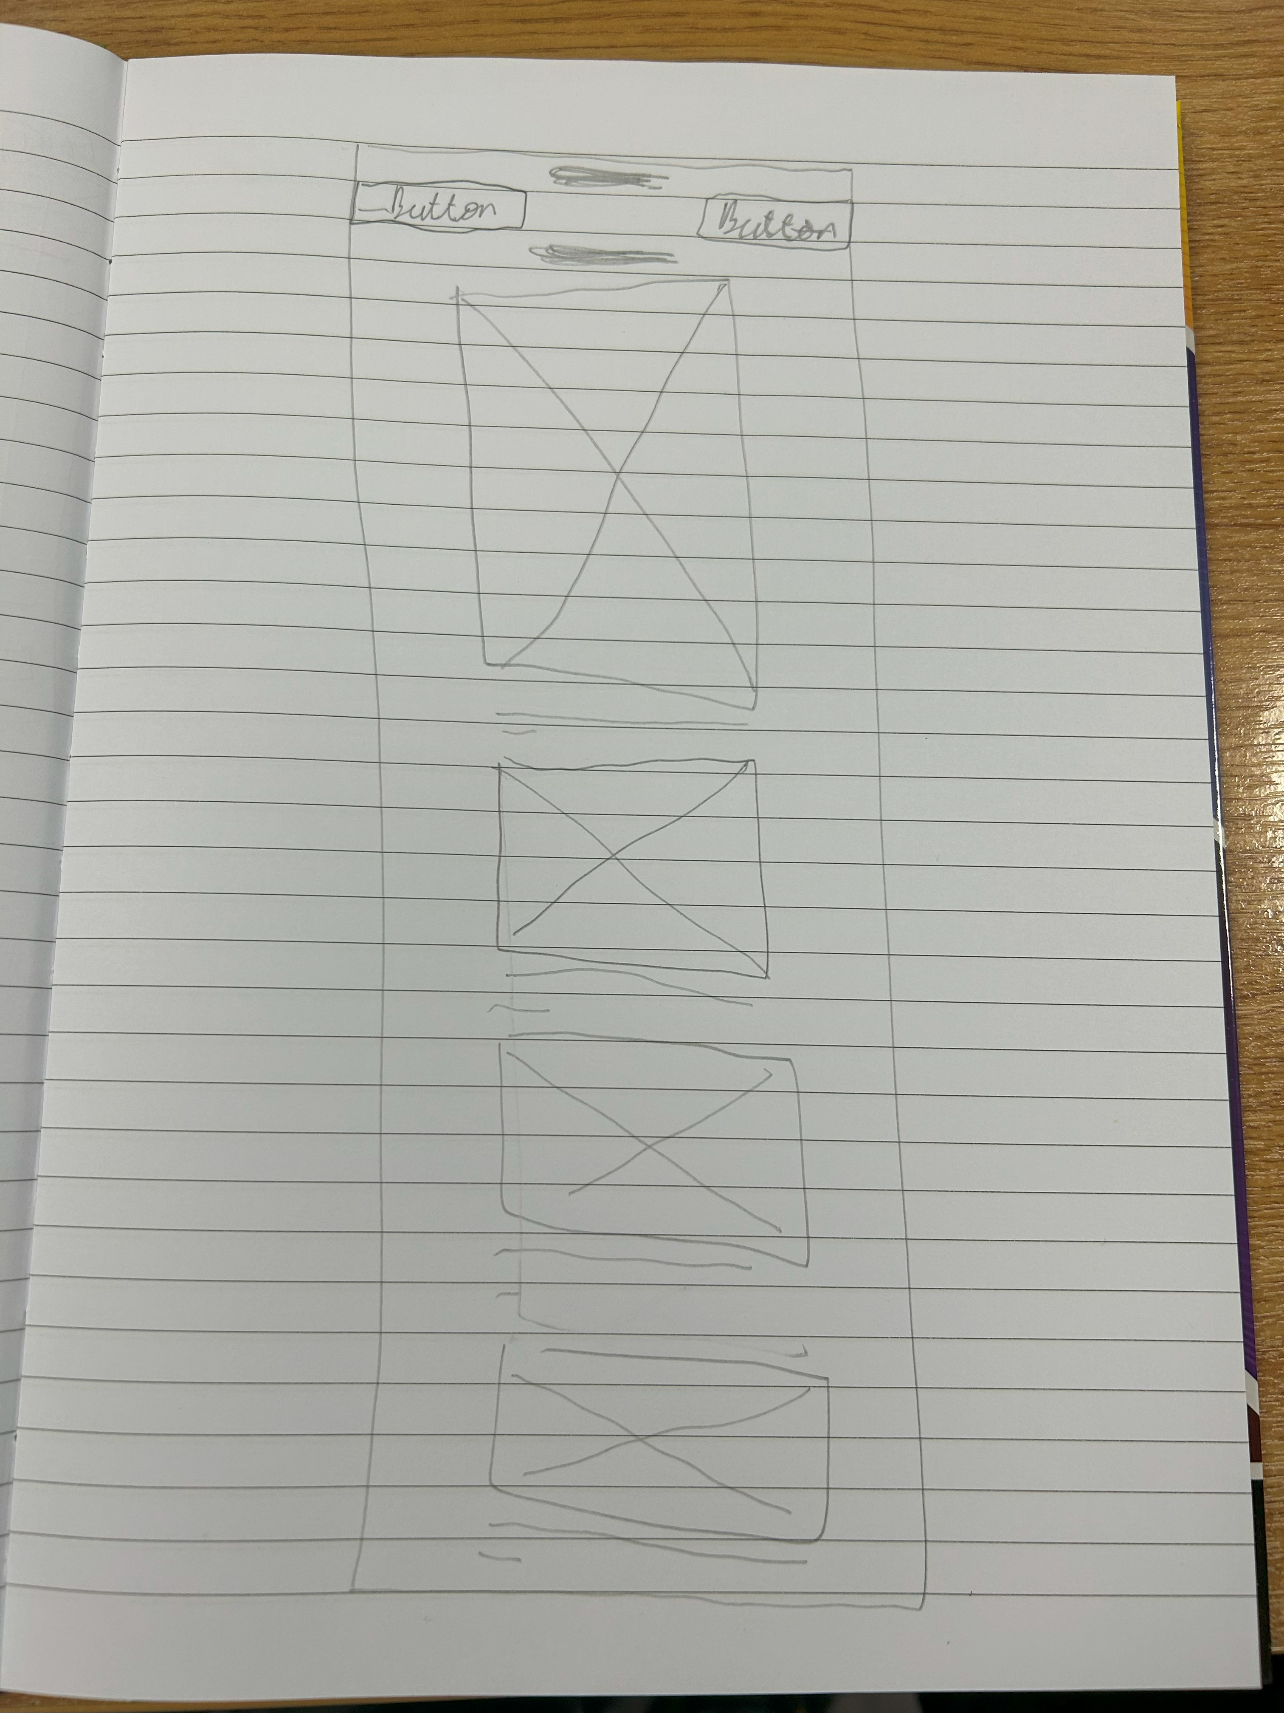

## Screen shot of sitemap

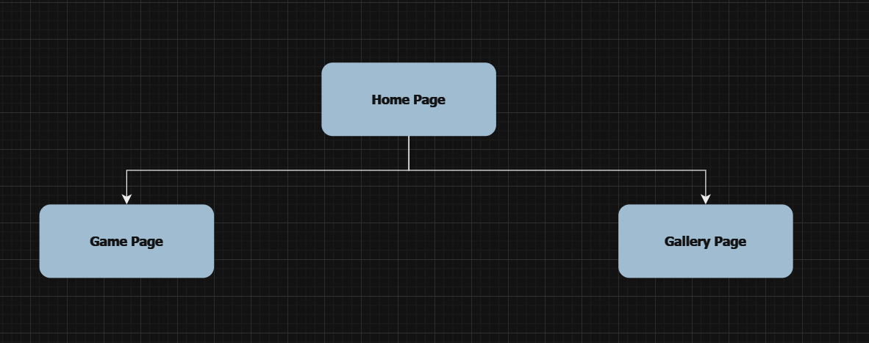

## Screen shot of Mood board:

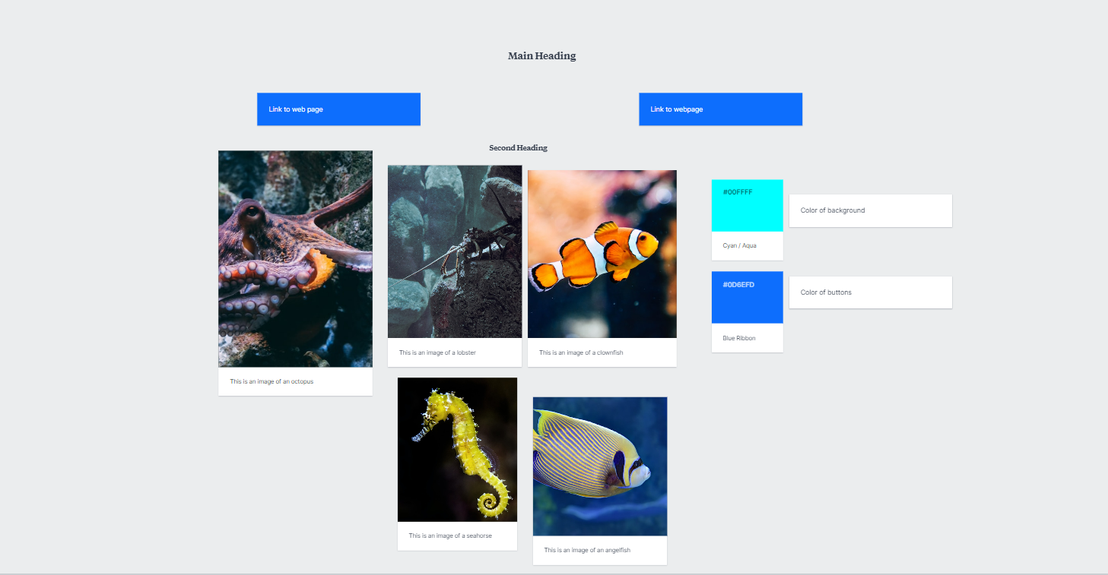

## Coding done by team member 1:

HTML

CSS

JavaScript

## Testing documented here:

HTML validation

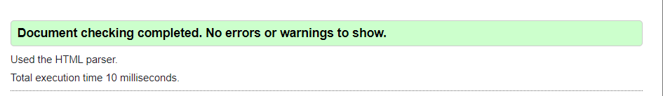

Create a table to show testing of menu links and JS, responsiveness

Deployment – speed test

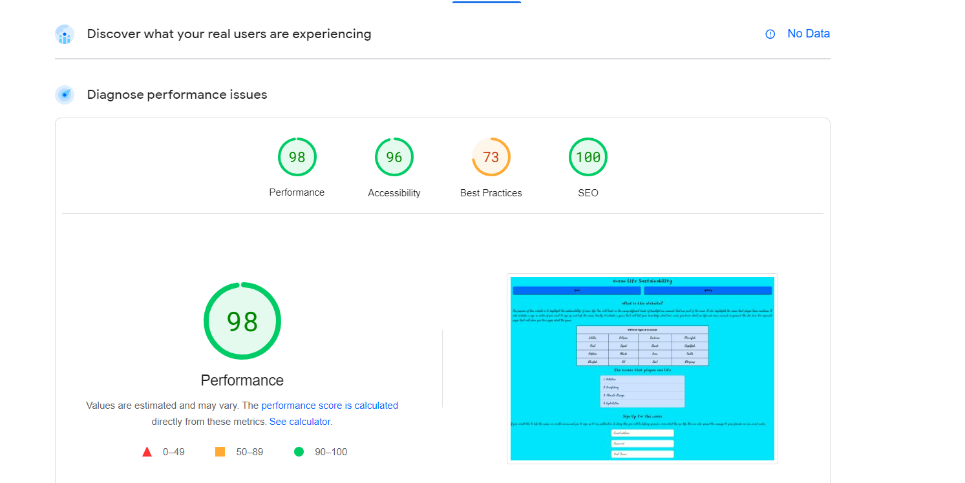

## Document the optimization of your images

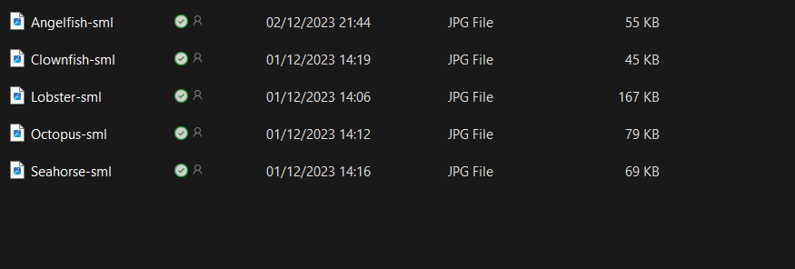

The file size of these images have been reduced so they load quickly.

## Document the planning (excel/other)

